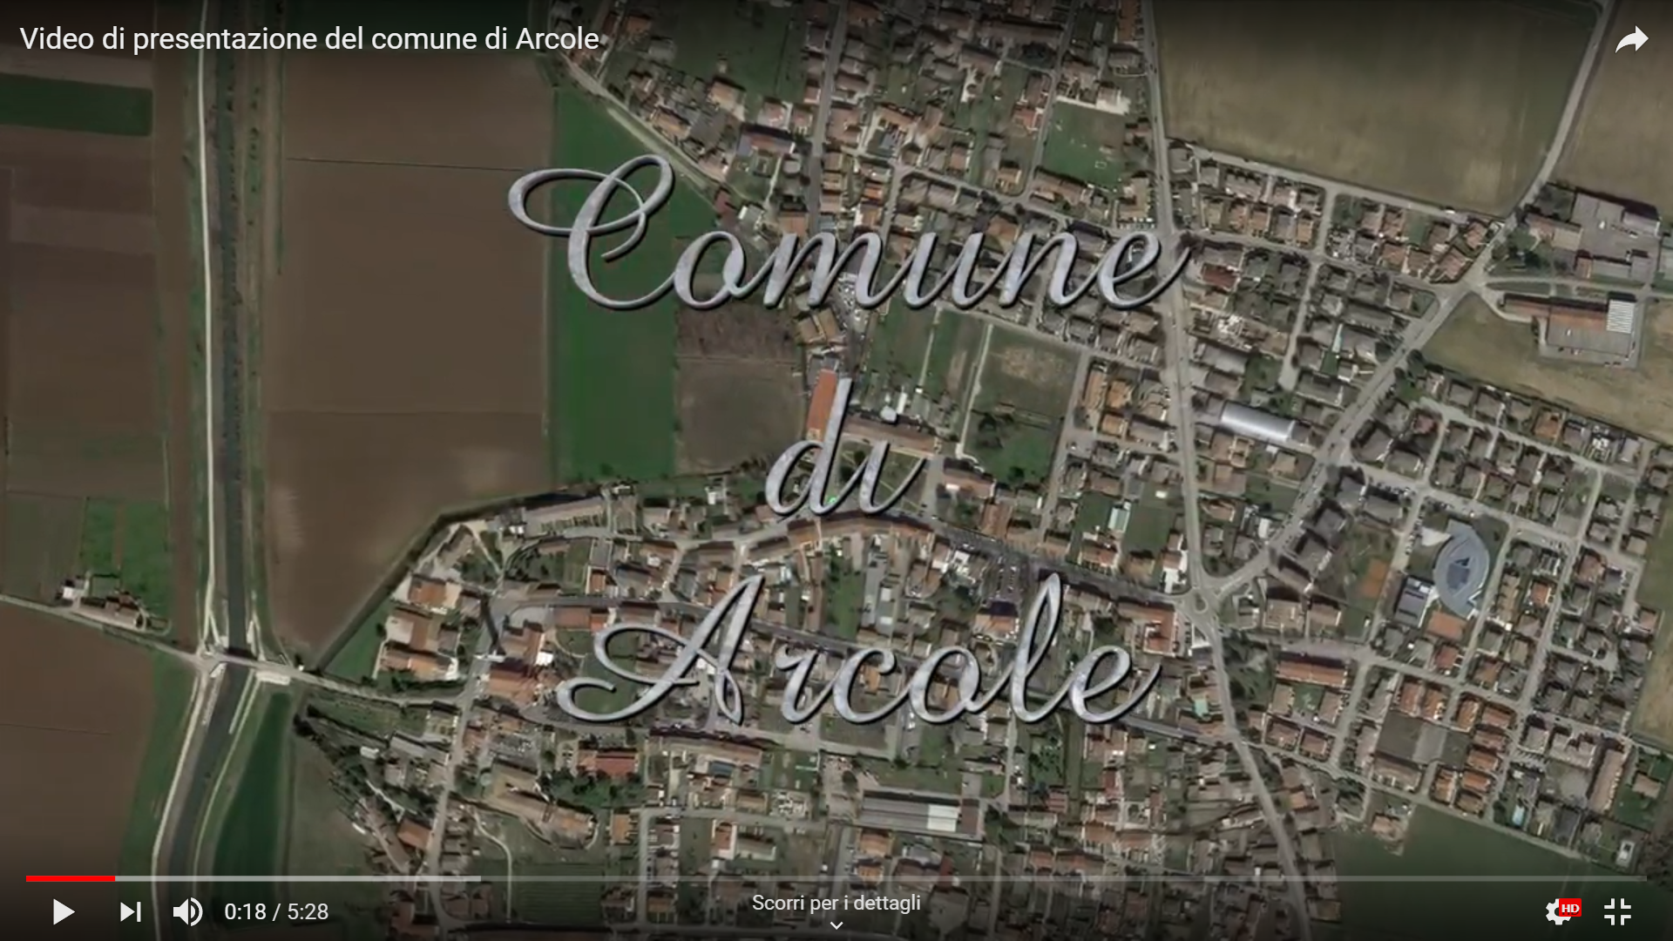

https://www.youtube.com/watch?v=KbT7QaGdFU4

